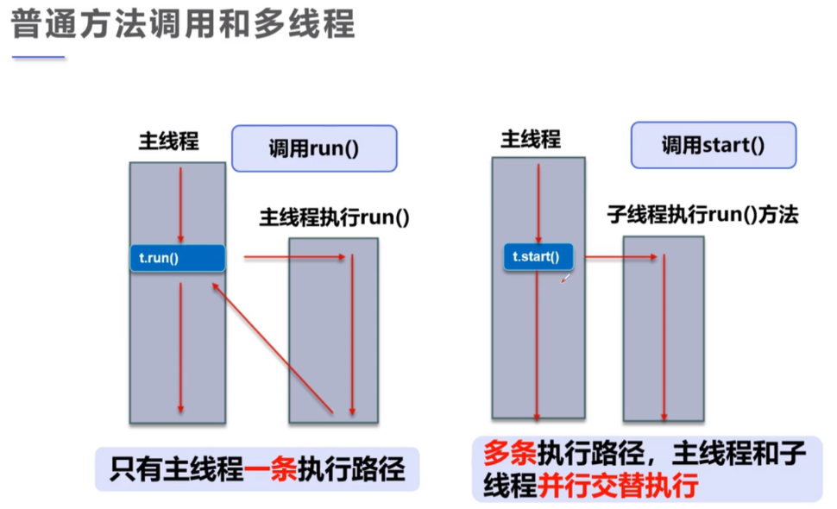

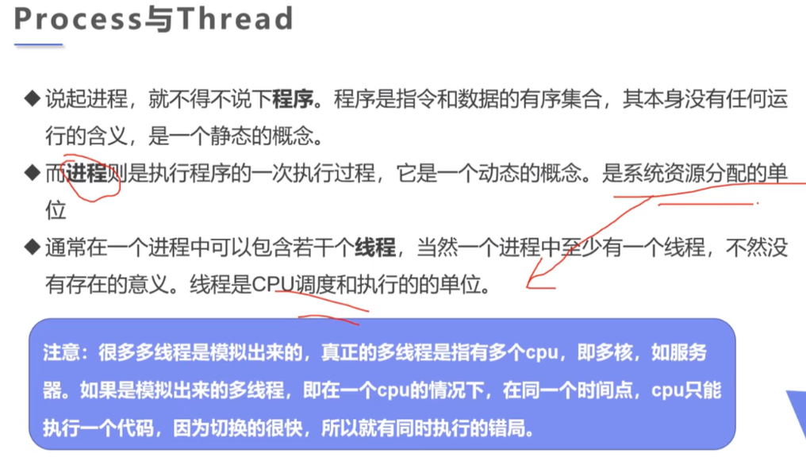

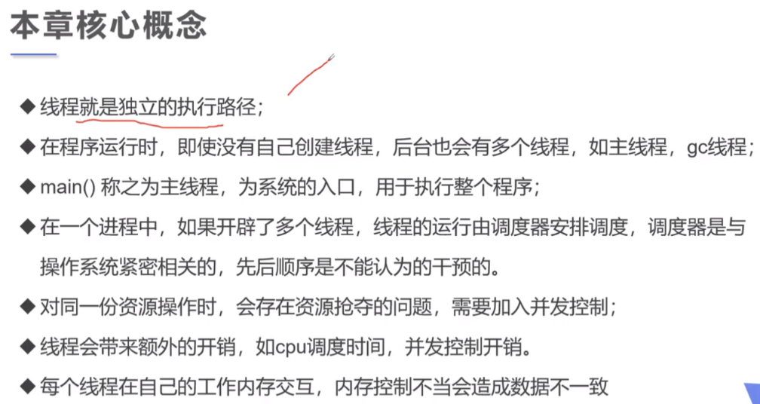

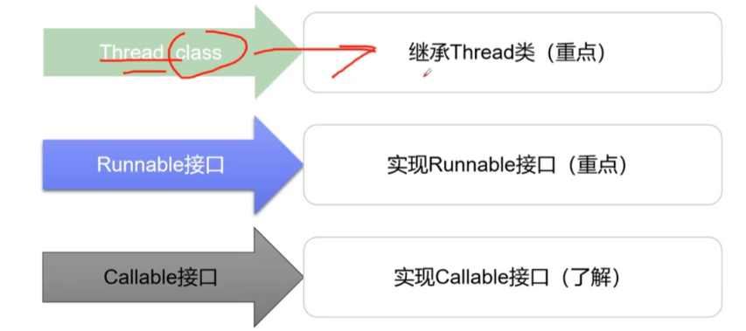

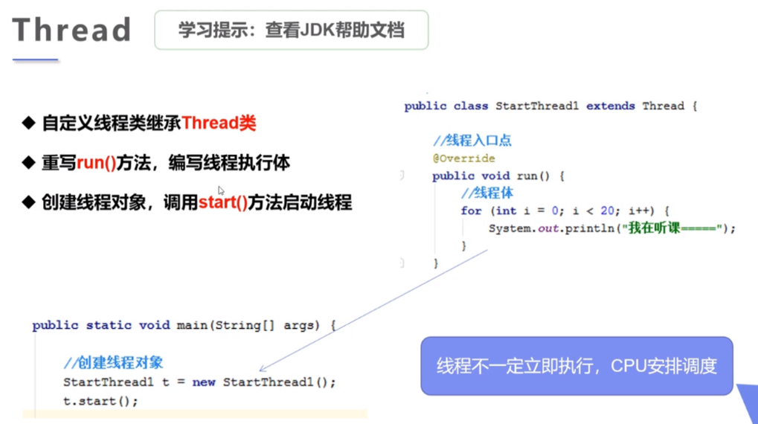

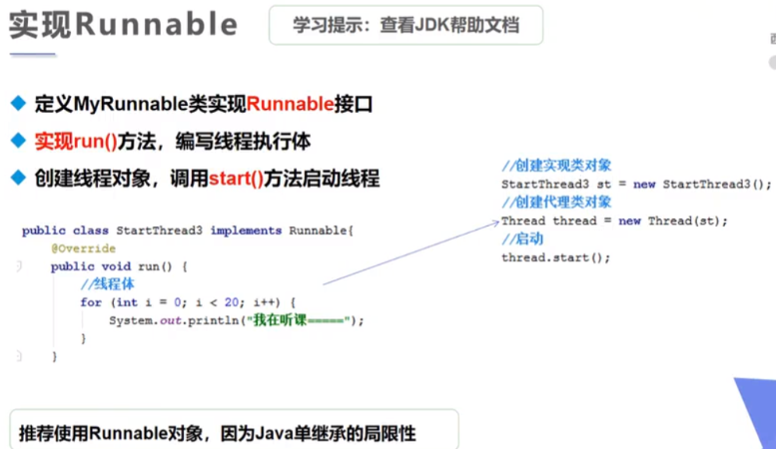

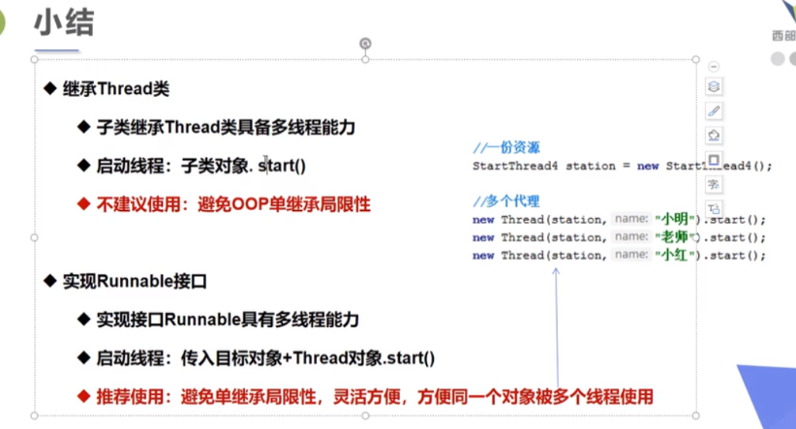

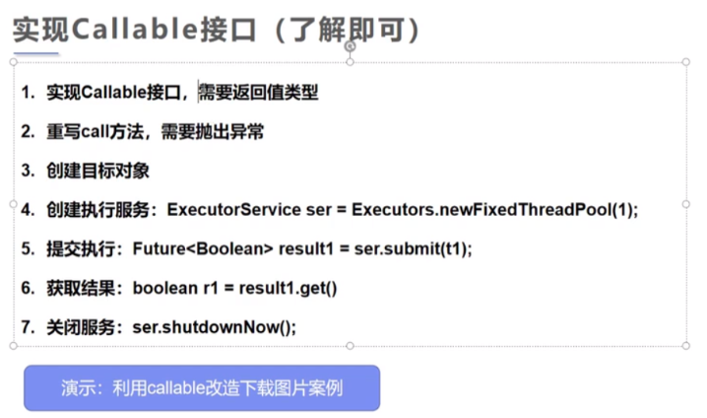

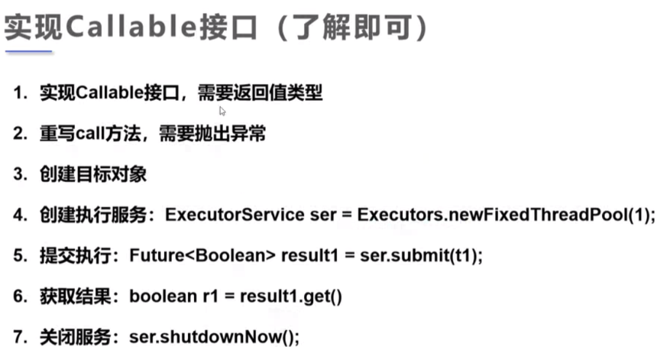

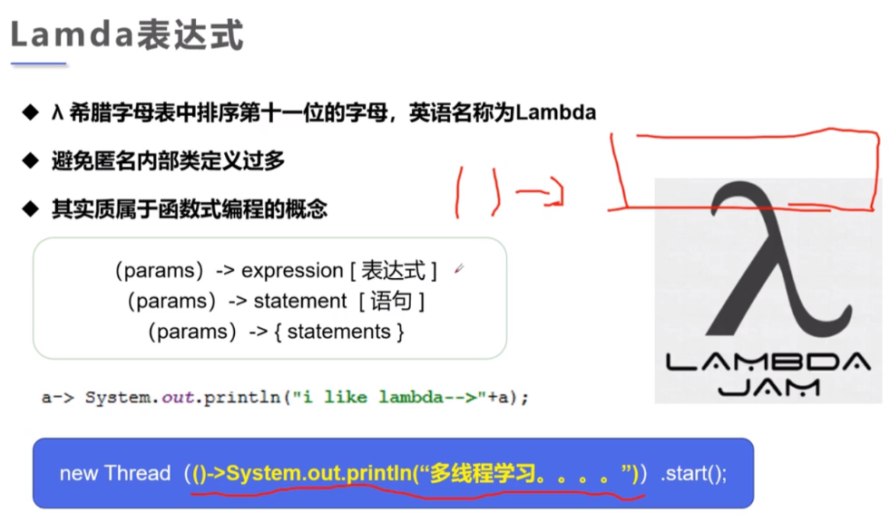

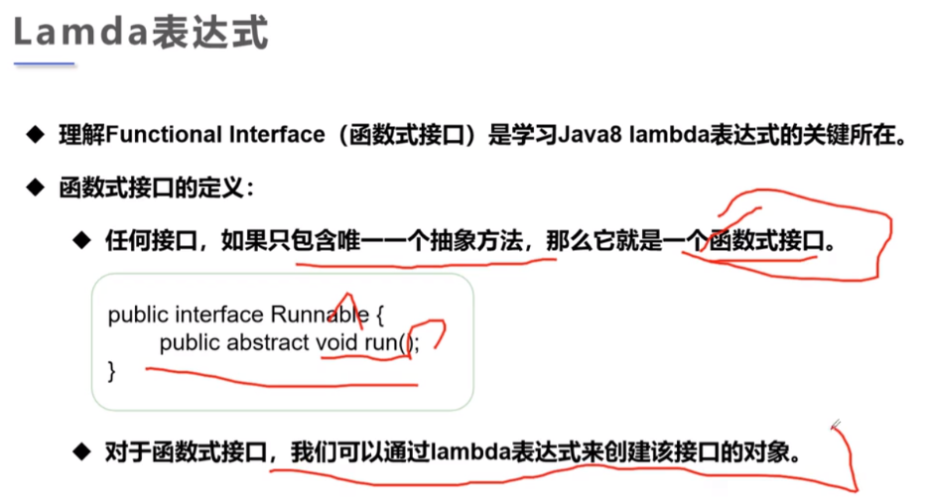

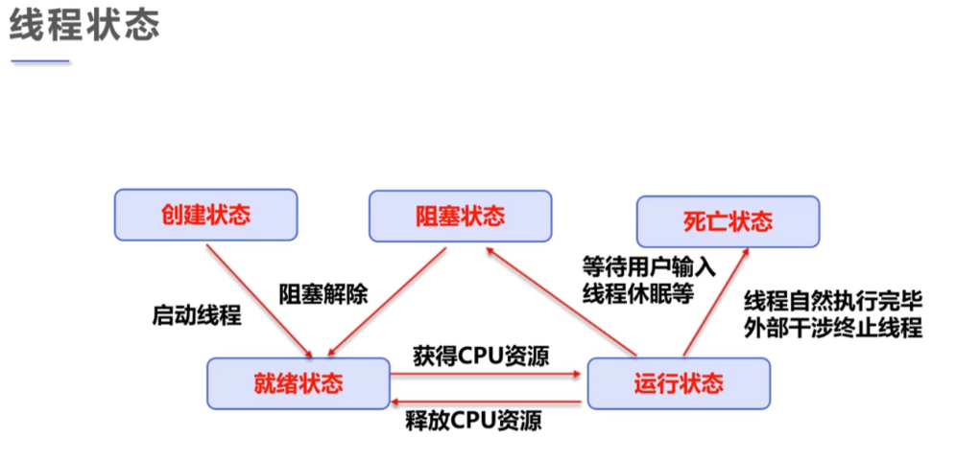

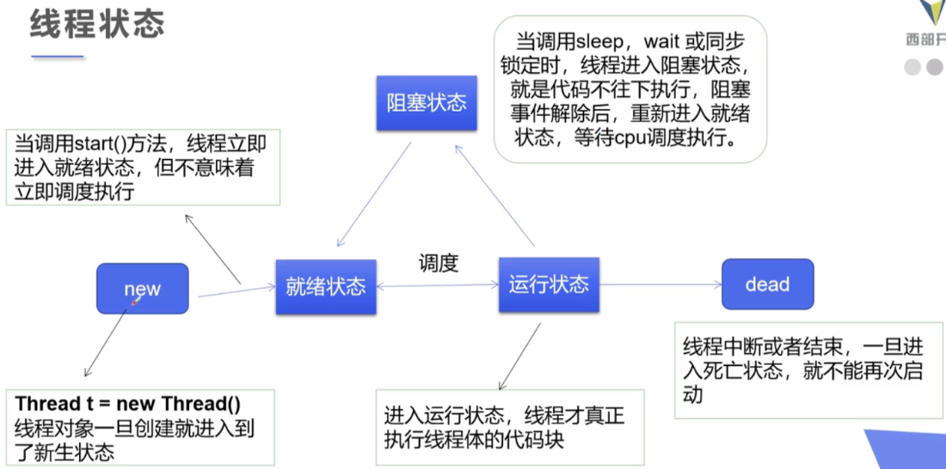

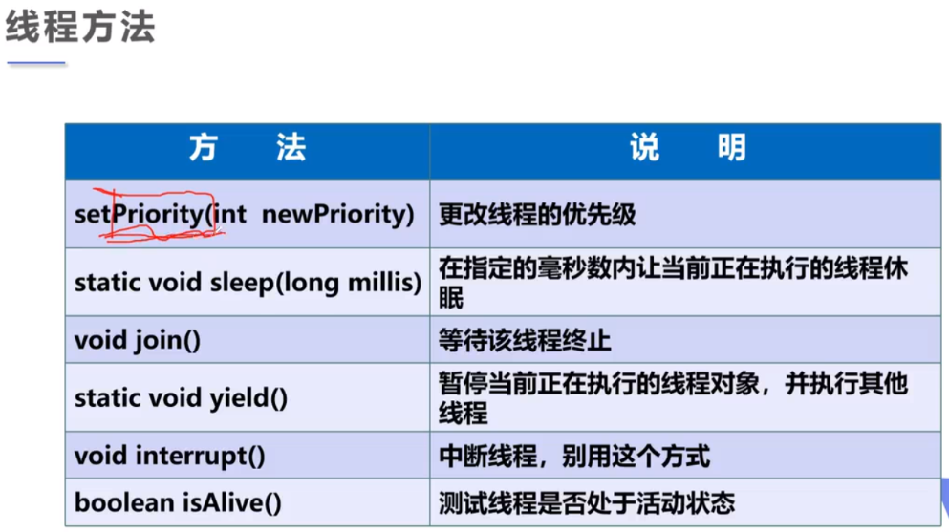

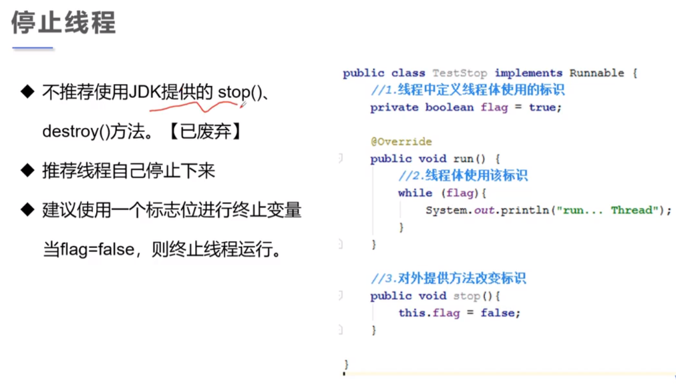

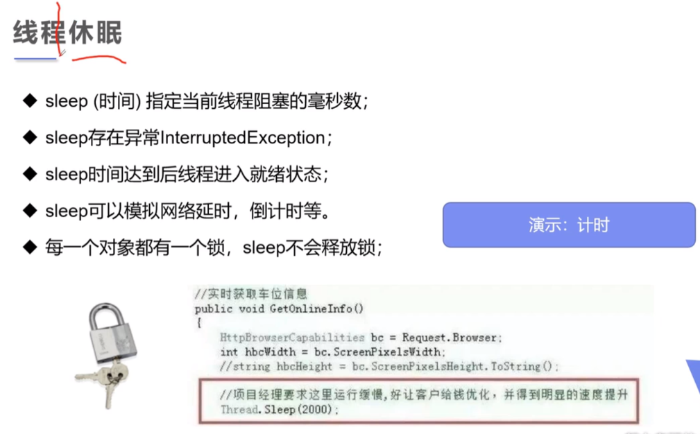

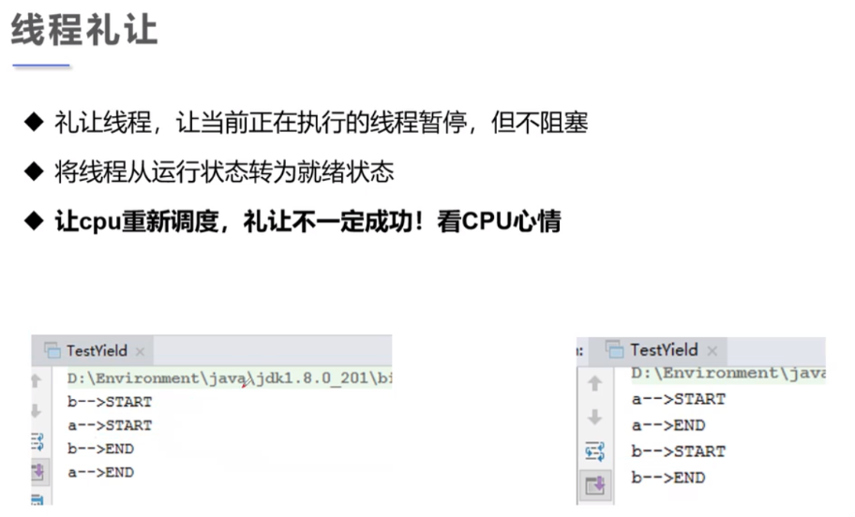

|  |
| --- |
| package com.wxiang.thread;  *// 测试线程礼让，所谓礼让就是让线程重新进入就绪状态，重新竞争cpu，礼让不一定成功，看运气* public class YieldTest {  public static void main(String[] args) {  MyYield myYield = new MyYield();  new Thread(myYield,"a").start();  new Thread(myYield,"b").start();  } }  class MyYield implements Runnable{   @Override  public void run() {  System.*out*.println(Thread.*currentThread*().getName() + " 线程开始执行..");  Thread.*yield*(); *// 礼让* System.*out*.println(Thread.*currentThread*().getName() + " 线程停止执行..");  } } |

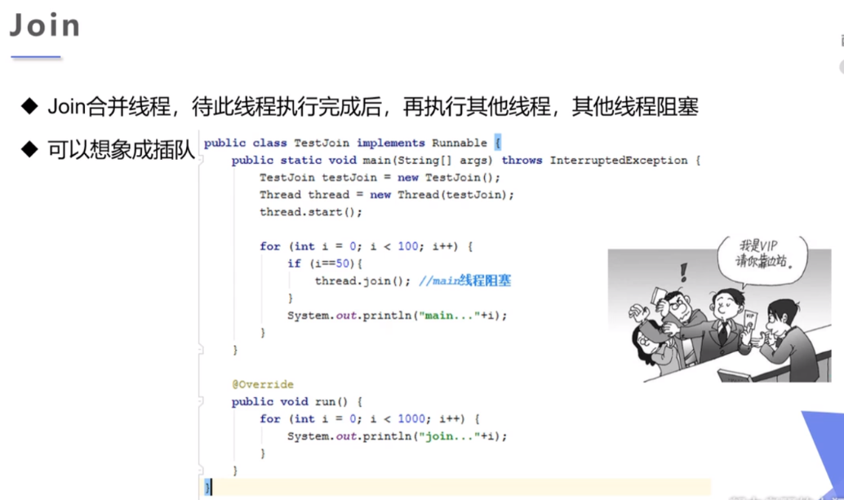

|  |
| --- |
| package com.wxiang.thread;  *// 测试join方法，类似插队* public class JoinTest implements Runnable{   @Override  public void run() {  for (int i = 0; i < 100; i++){  System.*out*.println("线程vip来了-->" + i);  }  }   public static void main(String[] args) throws InterruptedException {  JoinTest joinTest = new JoinTest();  Thread thread = new Thread(joinTest); *// 代理joinTest，增强joinTest的功能* thread.start();   for (int i = 0; i < 100; i++) {  if (i == 50){  thread.join(); *// main线程阻塞，thread线程执行* }  System.*out*.println("main "+ i);  }  } } |

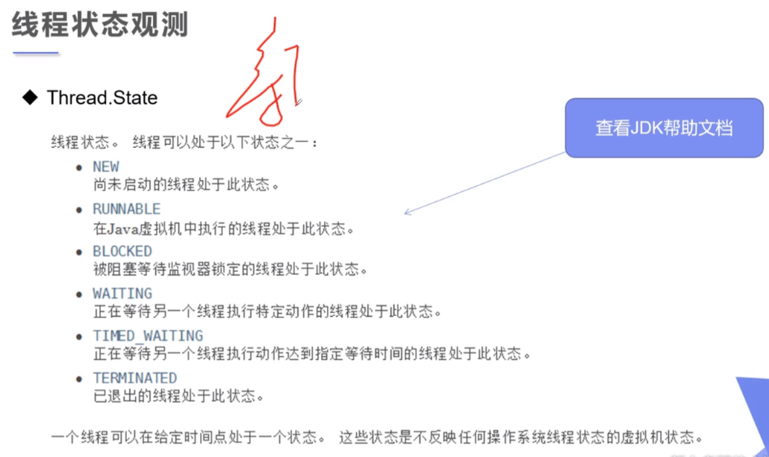

|  |
| --- |
| package com.wxiang.thread;  public class ThreadState {  public static void main(String[] args) throws InterruptedException {  Thread thread = new Thread(() -> {  for (int i = 0; i < 3; i++) {  try {  Thread.*sleep*(1000);  } catch (InterruptedException e) {  e.printStackTrace();  }  }  System.*out*.println("^_^_^_^_^");  });  Thread.State state = thread.getState();  System.*out*.println(state); *// NEW* thread.start();  state = thread.getState();  System.*out*.println(state); *// RUNNABLE  // 只要线程不终止就一直输出线程状态* while (state != Thread.State.*TERMINATED*){  Thread.*sleep*(100);  state = thread.getState(); *// 更新线程状态* System.*out*.println(state); *// 输出线程状态* }  *// thread.start(); // 报错，进入死亡状态的线程不能再次启动。* } } |

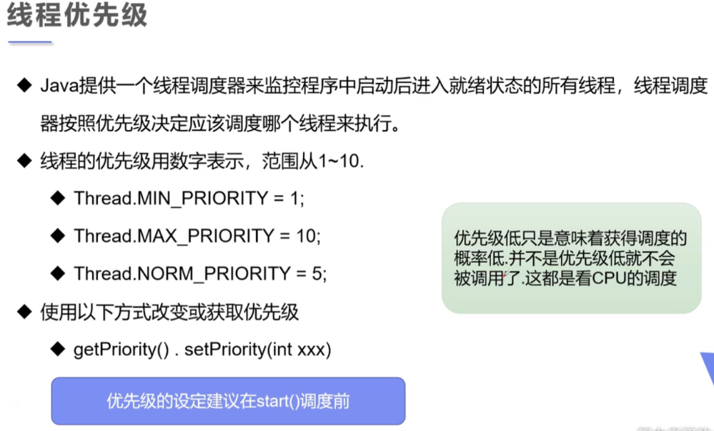

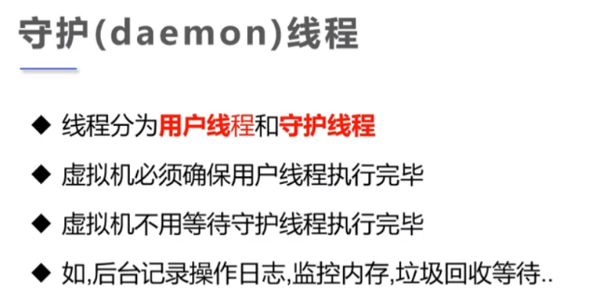

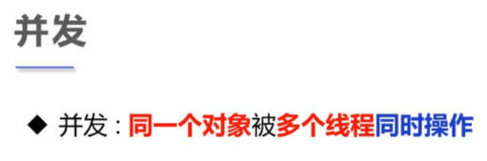

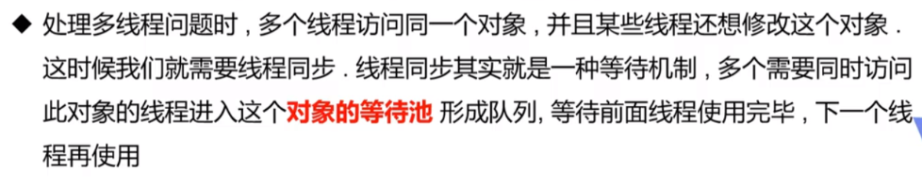

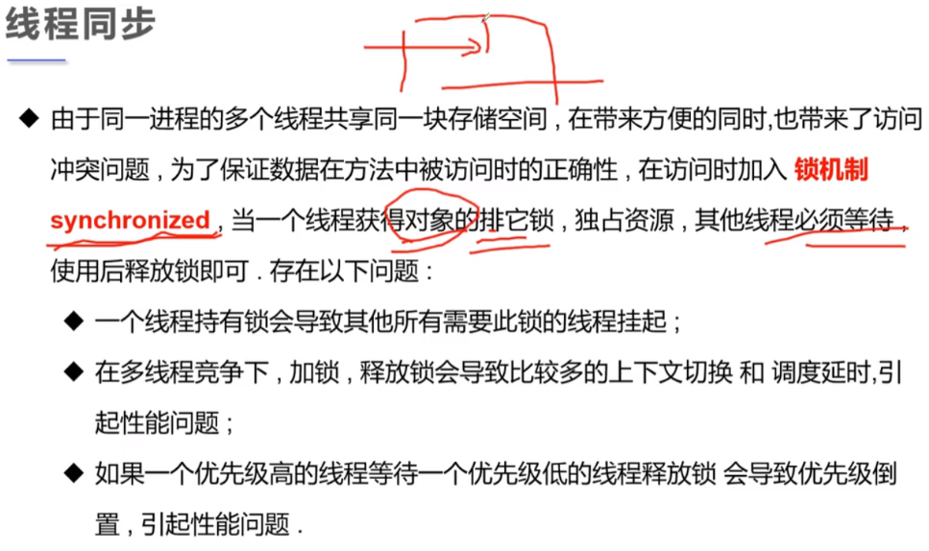

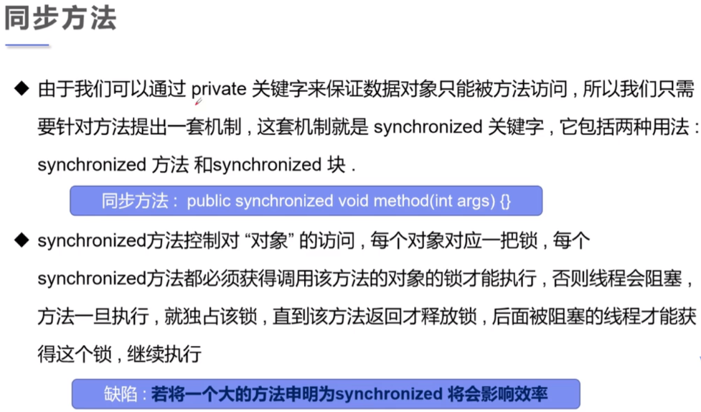

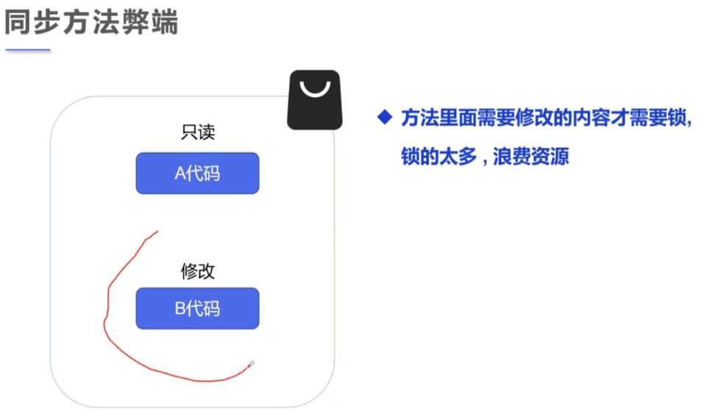

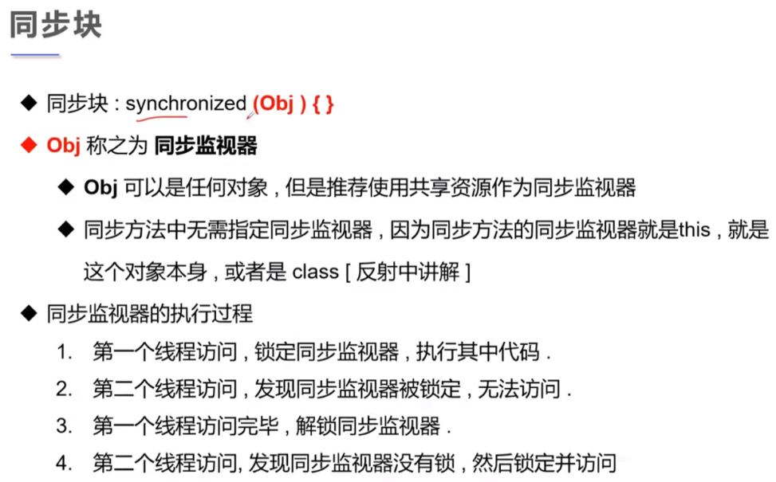

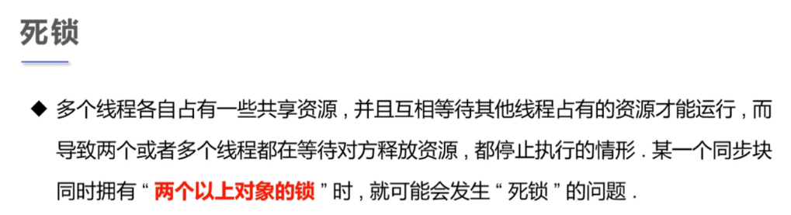

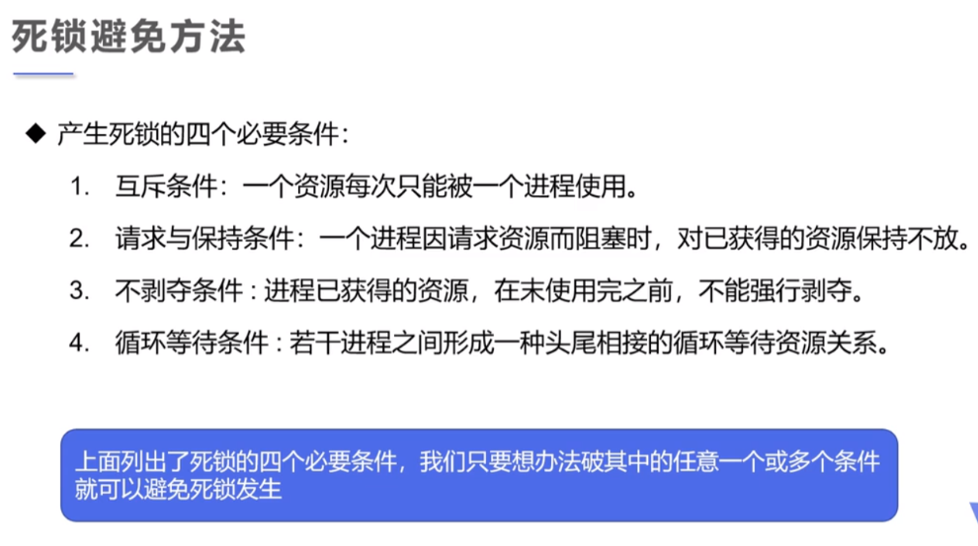

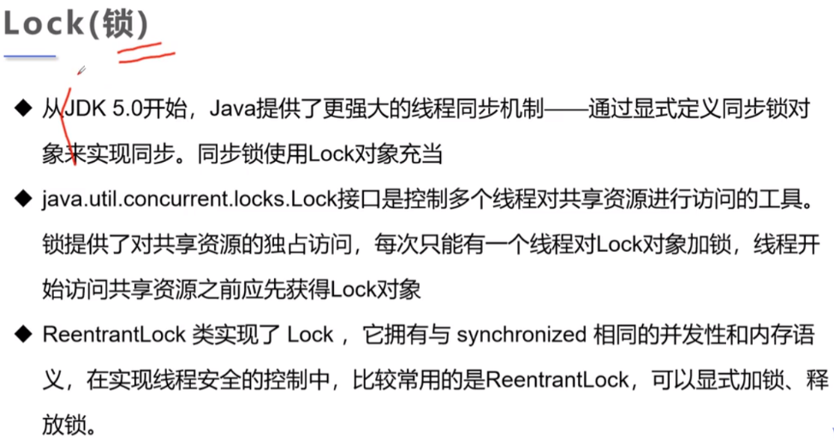

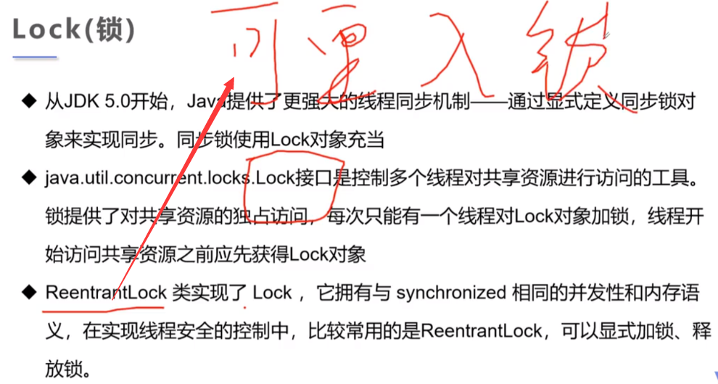

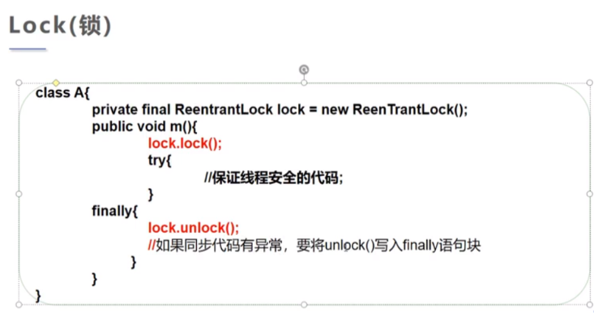

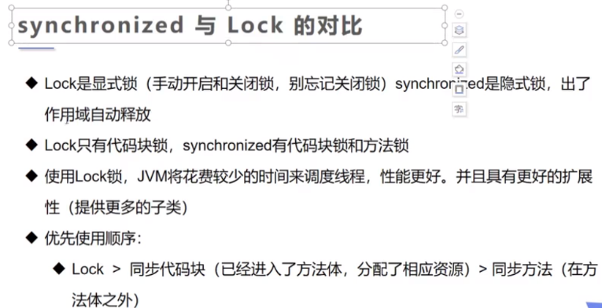

synchronized可阻止并发更新同一共享资源，实现了同步

synchronized不能用来实现不同线程之间的消息传递（通信）

